CAMPAIGNING

Four Day Week Ireland
The campaign for a shorter working week

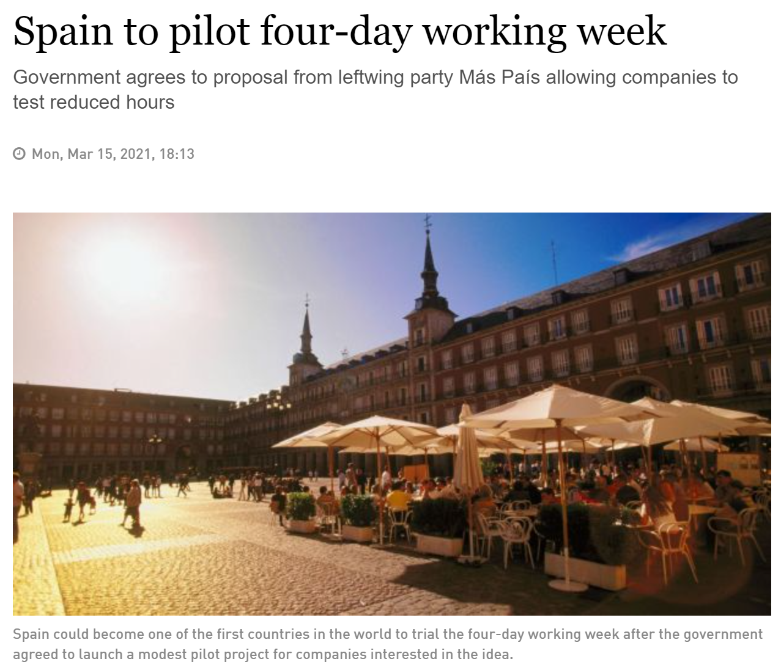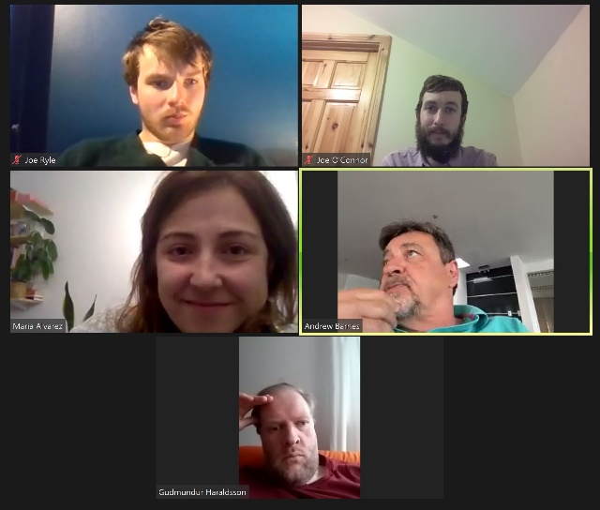

- We are in the final stages of developing and agreeing a research agreement with University College Dublin for the Four Day Week Ireland pilot programme. This will be led by UCD’s Assistant Professor Orla Kelly, and Juliet Schor, a Professor and economist at Boston College, New York Times bestselling author, and a foremost expert on working time, employee wellbeing and the future of work. Several meetings have taken place this month to develop and agree the details of this. Aileen O’Carroll from Maynooth University has also agreed to act as an adviser to the project. Initial meetings had been held with a researcher from TCD and an independent researcher advised to us by NERI, before deciding to proceed with the UCD/Boston College proposal.
- Meetings have commenced with officials and campaigners in Fórsa and other unions, to identify and target potential participant companies and employers for the pilot programme, in both the public and private sectors. Within Fórsa, our focus is on the local authority sector, where initial discussions have taken place with national secretary Peter Nolan, and the civil service, where following discussions with national secretary Derek Mullen a briefing was held with staff in the civil service division on March 11th. Andrew Barnes from 4 Day Week Global will be speaking at the Local Government and Local Services divisional conference on May 12th. Meetings were also held with SIPTU’s head of organising and campaigns Darragh O’Connor (18th Feb), FSU head of industrial relations and campaigns Gareth Murphy (5th March) and SIPTU deputy general secretary Ethel Buckley (12th March). A template letter of engagement has been developed to explain the pilot programme and set out our plans, to initiate informal conversations with possible participant companies and employers.
- The Four Day Week Ireland campaign wrote to the Tánaiste and Minister for Enterprise, Trade and Employment Leo Varadkar on March 10th, seeking to engage with him on our plans for the pilot programme, and seeking Government support in 3 ways: 1) Sponsoring the academic research, 2) Setting up a €5m financial aid fund to support participant companies in line with the Spanish pilot, 3) Committing to targeted public sector pilots in the local authority and civil service sectors. Discussions have also taken place with senior Green Party advisers on possible avenues for Government support of the academic research project.
- Following the launch of a four-day week pilot programme in Spain backed by the Spanish government, the first of its kind in the world, Director of Campaigning Joe O’Connor spoke to Newstalk Breakfast on Tuesday March 16th, and will speak to 2FM’s Louise McSharry Show on Saturday the 20th.
- We are continuing to work closely with our colleagues in the U.S. and New Zealand on the development of the global four-day week petition and coordinated international pilot, and a number of meetings have taken place in the past month to progress this. We represented the Irish campaign at an international meeting involving campaigners from the UK, Spain, New Zealand and Iceland on March 8th.
- A meeting of the Four Day Week Ireland steering group will take place on 19th March. Language will deliver a presentation on the campaign, website and social media strategy, and there will be an update presentation on the pilot programme and research.
- A meeting will take place with Claire Hellen, HR Strategy Specialist with IBEC, on March 23rd, to brief her on our plans for the pilot programme and seek IBEC’s support in making information on the pilot available to their members. On the same day, a meeting will be held with Sarah Lennon, a former employee of NZ-based global four-day week pioneers Perpetual Guardian who is now based in Ireland, in relation to joining the campaign coalition’s steering group.
- A schedule of 9 campaign blogs, which will be rolled out on Four Day Week Ireland social channels in the coming months, has been developed and agreed in conjunction with Fórsa’s Communications Unit. These will cover a variety of areas that the four-day week can benefit – for workers, business, society, the economy, the environmental, public health, mental health and so on.
- Work is ongoing to build the campaign’s Twitter presence and profile to reach more potential supporters, allies and key influencers. We are also developing a shortlist of potential public health and mental health organisations to expand the coalition to include this as a distinct pillar of the campaign.
Collective Bargaining
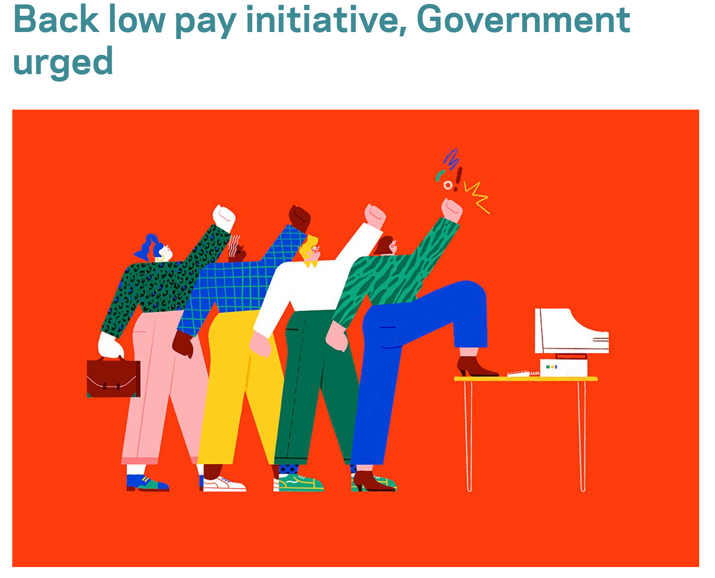
- A detailed Fórsa submission to the Department of Enterprise, Trade and Employment’s EU minimum wage directive consultation was submitted on 19th February, to complement the Irish Congress of Trade Unions submission.
- A press release was issued to complement this submission, and a response was later drafted and sent to a detailed set of queries from Brian Sheehan in Industrial Relations News, following consultation with Congress.
- Multiple engagements with political representatives and Enterprise, Trade and Employment spokespersons took place in relation to the SIPTU/FSU submission, including – Louise O’Reilly TD/Maurice Quinlivan TD/Senator Paul Gavan (Sinn Féin), Catherine Murphy TD (Social Democrats), Ged Nash TD/Senator Marie Sherlock (Labour), Senator Malcolm Byrne (Fianna Fáil), and Francis Noel Duffy TD/Senator Róisín Garvey (Green Party).
- The legal research project on collective bargaining rights in Ireland in a comparative European context is ongoing. A meeting with the primary and secondary researchers to discuss progress and next steps took place on March 8th. Part (1) of the research has been completed and Part (2) is at draft stage. Denmark, France, Belgium and the Netherlands were selected as comparative case studies on collective bargaining rights and coverage based on an agreed methodology. The project remains on track for completion in late April / early May.
- We have been working with the Language agency on developing an approach to undertaking qualitative and quantitative research on public awareness, understanding and attitudes to collective bargaining rights, to inform a common language and messaging to be adopted by trade union campaigners and communicators in the context of a new public campaign. A meeting was held on 12th March with SIPTU’s deputy general secretary to discuss this, and we are now exploring a collaborative project to be co-financed by the two unions.
- Meetings with ICTU, SIPTU and FSU have been held to discuss the campaigning landscape around collective bargaining, and discuss how we can work together to progress this issue.

Campaigning in Education – Care for Caretakers

- With schools having reopened, we are proceeding with the ‘Care for Caretakers’ recruitment campaign. WRC talks are progressing positively and there is still an expectation that we will be in a position to conduct a nationwide
- The materials for the direct mail campaign packs have been finalised in recent weeks, with quotes and photos from school caretakers, the school secretary branch chair and the INTO general secretary sought and secured. Logistics for print, fulfilment and distribution have been arranged. They are due to arrive in over 4,000 schools on 31st March, and complemented by electronic mail-outs to Fórsa school secretary members, and school principals via the INTO.
- A meeting with officials and organisers in the education division has been scheduled for March 30th, to discuss the rollout and implementation of the campaign. A special email address (caretakers@forsa.ie) has been set up to ensure speedy and efficient management of recruitment queries by campaigning and education staff. Keyrings, business cards, and specialised welcome letters will be issued to all new members over the course of the campaign.
Branch Campaigns Officers

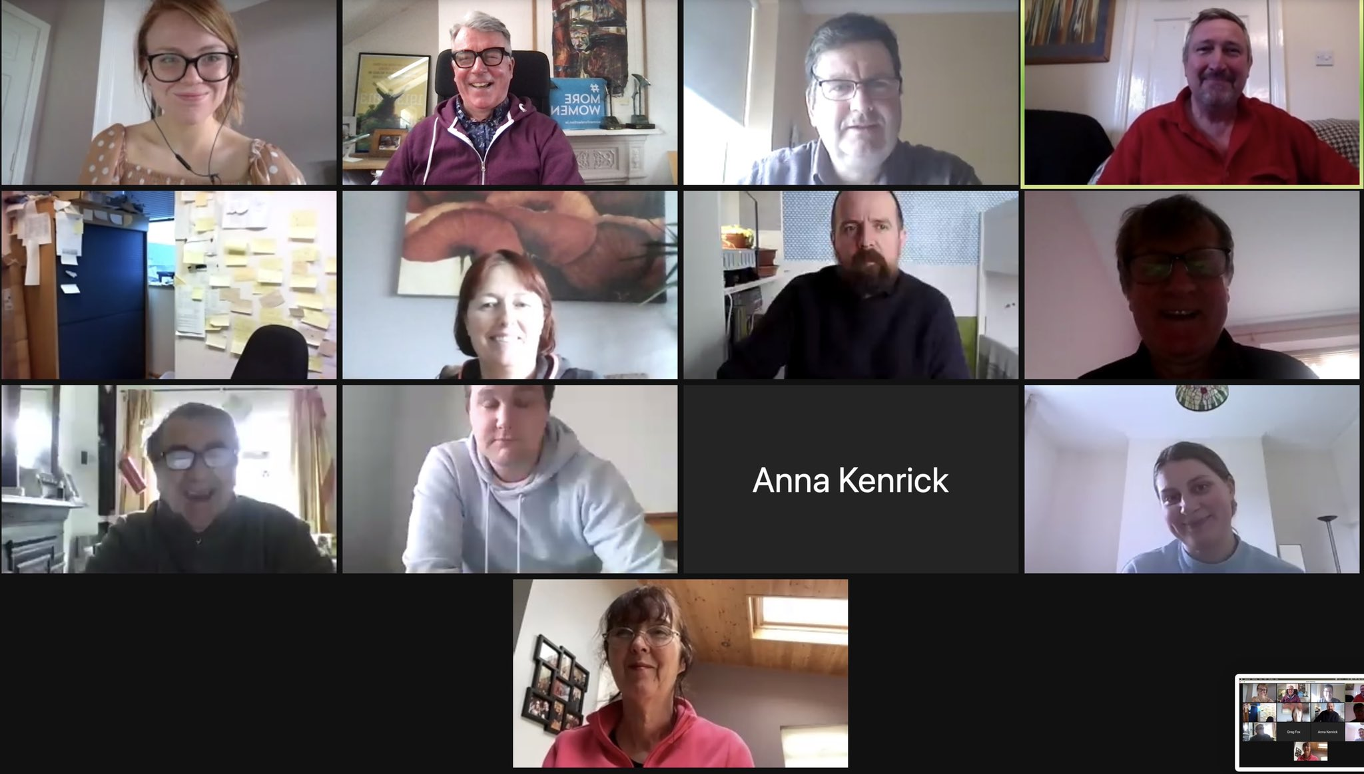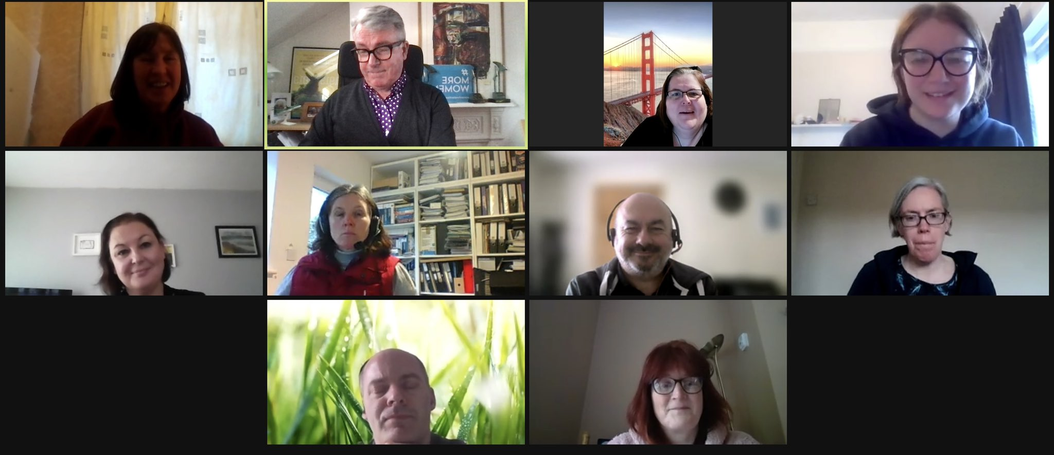

- More than 30 branch campaigns officers participated in 2 full days of training in 2 groups – on March 4th and 11th, and March 5th and 12th. The training covered political lobbying and influencing the political system, engaging with local media, building confidence, public speaking and presentation skills, and storytelling. It was led by Pat Montague of Montague Communications and Catherine Raynor from Mile 91. A presentation was also delivered updating BCOs on current and planned campaigns activity, and the training workshops were focused in a practical way on how the training content could be implemented for these campaigns.
- We are in the process of finalising both a mentoring system and a communications channel for BCOs.
Campaigning in Health – ‘Section 39’ workers
- The union’s research on organisations funded through ‘Section 39’ of the Health Act, which is being carried out by independent researcher Brian Harvey, is at final draft stage and is approaching finalisation. This was informed by surveys issued to hundreds of employers and thousands of workers in the sector, and expert interviews with worker representatives, IR practitioners, employers and policy makers.
- Once complete, the research report will be designed and launched via a webinar intended to engage political representatives and key decision-makers as well as our members in this area. A meeting will be held with the national health team to agree next steps, and the findings and recommendations of the report will be used to inform the creative process for the next stage of our campaign in this area.
Additional Items
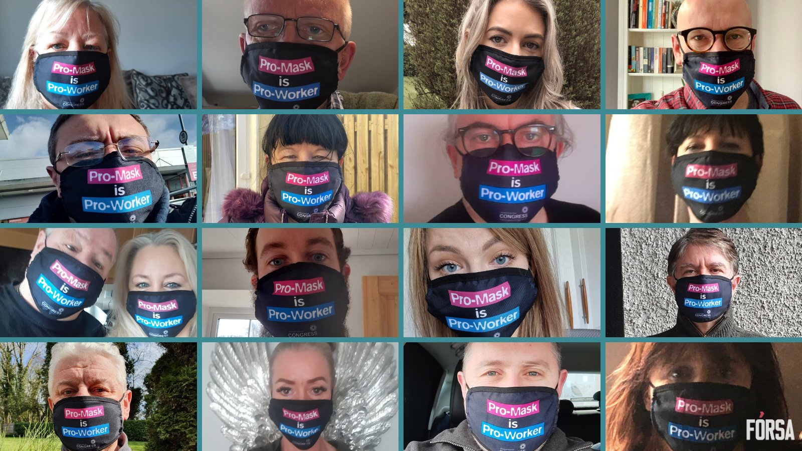
- ICTU ‘Pro Mask is Pro Worker Campaign – Following two meetings this month to agree the approach and messaging for this campaign, Fórsa supported this ICTU-led social media campaign on St. Patrick’s Day, to counter the harmful anti-public health disinformation being perpetuated online by ‘far right’ groups. Facemasks were distributed to staff and activists, who were encouraged to take selfies and send their stories in support of the campaign. These were collated and posted by Fórsa’s Communications Unit.
- Aviation Industry / Cabin Crew Campaign – Briefing meetings were held with a number of cross-party TDs and senators, focusing on the membership of the Oireachtas Transport Committee.
- Housing / Home for Good Campaign – Fórsa were represented at meetings held of the HFG steering group, building the coalition and political engagement groups this month, with the latter focused on preparations for meetings with the Minister for Housing Darragh O’Brien and Minister for Transport Eamon Ryan.
- PR Awards / Support our Secretaries Campaign – We have submitted a nomination to the Public Relations Awards with Montague Communications and Persuasion Republic for the ‘Support our Secretaries’ campaign.
- Cork Trade Union Studies – Fórsa’s Director of Campaigning participated in this QQI accredited programme being run by ICTU/SIPTU College as a guest speaker on March 11th.
- Climate and Biodiversity – Fórsa are preparing comments as part of the NESC consultation process on climate and biodiversity, closing March 19th.
- Future of Work – Fórsa’s Director of Campaigning participated in an interview on the Future of Work with the Europe Direct Information service on February 19th. We also attended a Future of Work event held by the Employment Bar Association on March 18th, which was addressed by the Tánaiste, IBEC’s Danny McCoy and TASC’s Shana Cohen.

