CAMPAIGNING

Campaigning Review / Work Programme
- A review of all current and ongoing public and political campaigns is underway, and a new campaigning work programme is being developed which is aligned with Fórsa’s strategic, industrial and organising objectives. This is also considering campaigns which are dormant or paused, or potential campaigns which are at concept stage.
- The following areas are being taken into account as part of this review:
- Mix of national and divisional priorities
- Current resource allocation and future resource requirements
- Impact of COVID19 pandemic on campaign activities
- Progress made to date towards intended outcome, and assessment of current position
- The strategic objectives contained in Section 3 of Fórsa’s strategic plan on ‘Campaigning and Influencing’ are also being considered to inform the review and work programme development, as well as motions submitted to Fórsa’s national conference by the NEC and branches which are relevant to campaigning.
- Meetings have taken place with the heads of division for the health & welfare, civil service, education, local government and municipal divisions to discuss campaigning priorities, resourcing and sequencing. Immediate priorities, ongoing activities and future developments have all been agreed within resource parameters. A meeting with the new services & enterprises head of division will be arranged in the coming weeks.
- A presentation on the emerging priorities and recommendations from the review and divisional engagements was delivered at a meeting of the Strategic Organising & Union Development team on the 12th of November, and group and individual meetings with team members will take place in the coming weeks, commencing with schools organisers on the 18th of November.
- A full report on the campaigning review and new work programme will be circulated to the December NEC.

Four Day Week Ireland
The campaign for a shorter working week
- A meeting of the Four Day Week Ireland steering group took place on October 29th, where the next steps following the successful survey launch were discussed.
- The four-day week has been included on the new work programme for the Oireachtas Committee for Enterprise, Trade and Employment, along with remote working and flexible working as part of a theme on ‘New Ways of Working’.
- A number of meetings are taking place as regards the global campaign for a four-day week. The ETUC are developing a European campaign on the shorter working week, and a meeting with ETUC Vice-President Esther Lynch took place on November 3rd. A meeting with the campaign coordinator for the 4 Day Week US campaign took place on November 17th. There will be an international meeting of campaign leaders being organised by the 4 Day Week UK campaign on November 27th.
Campaigning in Schools
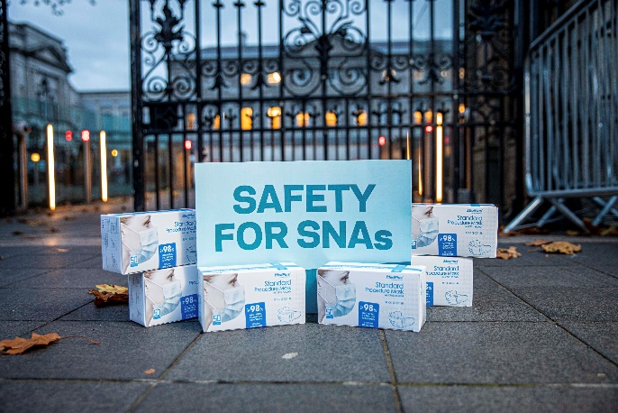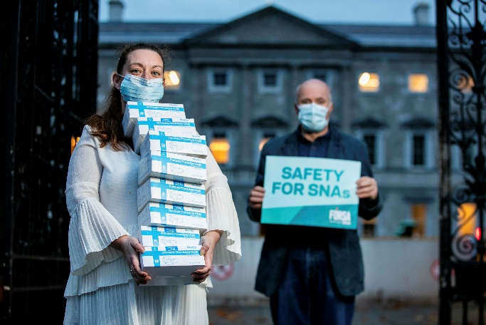

- The political breakthrough in the ‘Support our Secretaries’ campaign which was reported last month has been formalised through an enabling agreement to regularise the pay, conditions and pensions of school secretaries working in grant-funded schools. This followed continued intensive high-level political engagement and lobbying with Government representatives, in addition to Opposition pressure. Technical discussions will now commence to ensure delivery on these high-level commitments.
- A meeting took place on October 19th to brainstorm on maximising recruitment of school caretakers, building on the successful approach to building profile adopted in the ‘Support our Secretaries’ campaign which led to the increase in branch members by over 50% from the beginning of 2019 to date. This will utilise similar tactics, using SNAs, school secretaries, school principals and direct mailing to reach school caretakers.
- A significant amount of political engagement has been ongoing in relation to SNA issues. We worked with the Communications Unit to issue a press release highlighting school safety issues for SNAs, relating to the non-requirement for schools to provide medical grade face masks, in settings where SNAs are unable to maintain social distance from pupils who are unable to wear face masks. This was complemented by a series of questions raised on Fórsa’s behalf by Opposition education spokespersons through PQ’s, the education committee and Leaders questions, as well as a photo call held outside of Leinster House to highlight the issue. Additionally, following the DES communicating their position that the ’72 hours’ for SNAs should be mandatory, we worked to get this issue raised in the Oireachtas.

Education Futures
The campaign for publicly-funded higher education
- The ‘Education Futures’ campaign is a coalition of higher education trade unions and students’ unions, advocating for a publicly-funded higher education system which delivers accessible, affordable and quality education for students, as well as decent work for staff. The campaign coalition has been chaired by Fórsa since its inception in 2016.
- The group is drafting a work plan for 2021. The primary objectives of this will be to build the campaign’s audience and reach, broadening the coalition by reaching out to new stakeholders, and engage with upcoming departmental consultations.

Housing Campaigns
Homes for Good
- Fórsa have been the trade union representatives on the campaign steering group of ‘Homes for Good’, the campaign for a right to housing, since the inception of the campaign.

- The Homes for Good campaign delivered a presentation to the Oireachtas housing committee on the 3rd of November.
- Following a commitment in the programme for government to a referendum on the right to housing, the campaign has now established a number of sub-committees.
- Fórsa are members of the “building the coalition” and “winning the referendum” sub-committees. Each of the committees have held initial meeting and will be drafting specific work plans before the Christmas break.

Raise the Roof
- The Raise the Roof campaign will be hosting a webinar on tackling the housing crisis at the event of November. Fórsa is assisting with the organisation of this event. Contributors include experts in the areas of housing policy, planning and urban design, as well as political speakers.

Additional Items
- The Director of Campaigning contributed to a video developed for Fórsa’s virtual conference to review the highlights of Fórsa’s first three years in existence, discussing some of the major campaigns the union have engaged in over this time period.
- The activities of the branch campaigns officer network have been curtailed as a result of the impact of the COVID-19 pandemic. In the coming weeks we will be seeking to reengage and revitalise the network through activating existing BCOs and expanding branch participation. A web event with current and potential BCOs will be held in December. Our objective is to have an active Fórsa campaigns group established in every county and constituency, with a network of over 100 BCOs.
- Given the strong participation and positive feedback for the Campaigning Summer Series webinars, it has been decided that future Campaigning Summer School events will adopt a blended approach between in-person attendance and live streaming.

