CAMPAIGNING

Four Day Week Ireland
The campaign for a shorter working week
- Plans are being developed to develop a ‘Four Day Week Institute’, which offers academic research support, training, coaching & mentoring, and accreditation to approved pilot programmes of the four-day working week. It is planned to launch this in the coming months in advance of a September rollout of pilots across different sectors.
- To develop the above, meetings have been held with the ICE Group (7th January) in relation to developing a training programme on implementing a four-day week trial, with 4 Day Week Global (12th January) on providing a leadership, coaching and mentoring resource, and with professors and academics in the Departments of Sociology and Business in Maynooth University in relation to the research collaboration.
- A meeting has also been scheduled to take place on January 21st with Donegal-based firm 3D Issue who have adopted the four-day week, and with US tech firm Kickstarter on January 25th who are one of the largest firms internationally to embrace the concept of the four-day week.
- A submission was made by the campaign via ICTU to a question on the four-day week raised at the Citizens Assembly on gender equality.

Campaigning in Education
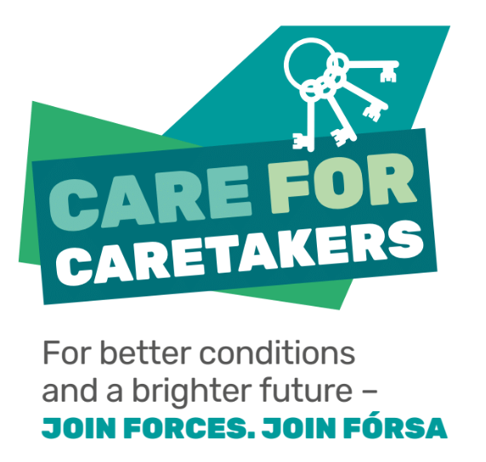

- The branding, messaging and materials for Fórsa’s school caretaker recruitment campaign – called ‘Care for Caretakers’ have been developed throughout December and January and are approaching finalisation. This process has been informed by a survey of school caretakers, phone banking and interviews. The campaign will utilise similar tactics to the successful recruitment campaign as part of ‘Support our Secretaries’, channelling Fórsa members working in schools (SNAs and school secretaries) and school principals as a conduit, and using direct mailing of campaign packs to reach school caretakers. The print, fulfillment and distribution of these packs was intended to take place in January, however this has been postponed by a few weeks due to the delayed reopening of schools.
- Ongoing and intensive political engagement has taken place with Oireachtas education spokespersons in relation to issues affecting Fórsa’s Special Needs Assistant members, particularly in relation to health and safety concerns around the Government’s reopening plan.
- The Director of Campaigning addressed the AGM of the school secretaries branch on 14th January, to reflect on the success of the ‘Support our Secretaries’ campaign in delivering a political breakthrough on respect and fair conditions for school secretaries.
Campaigning in Health

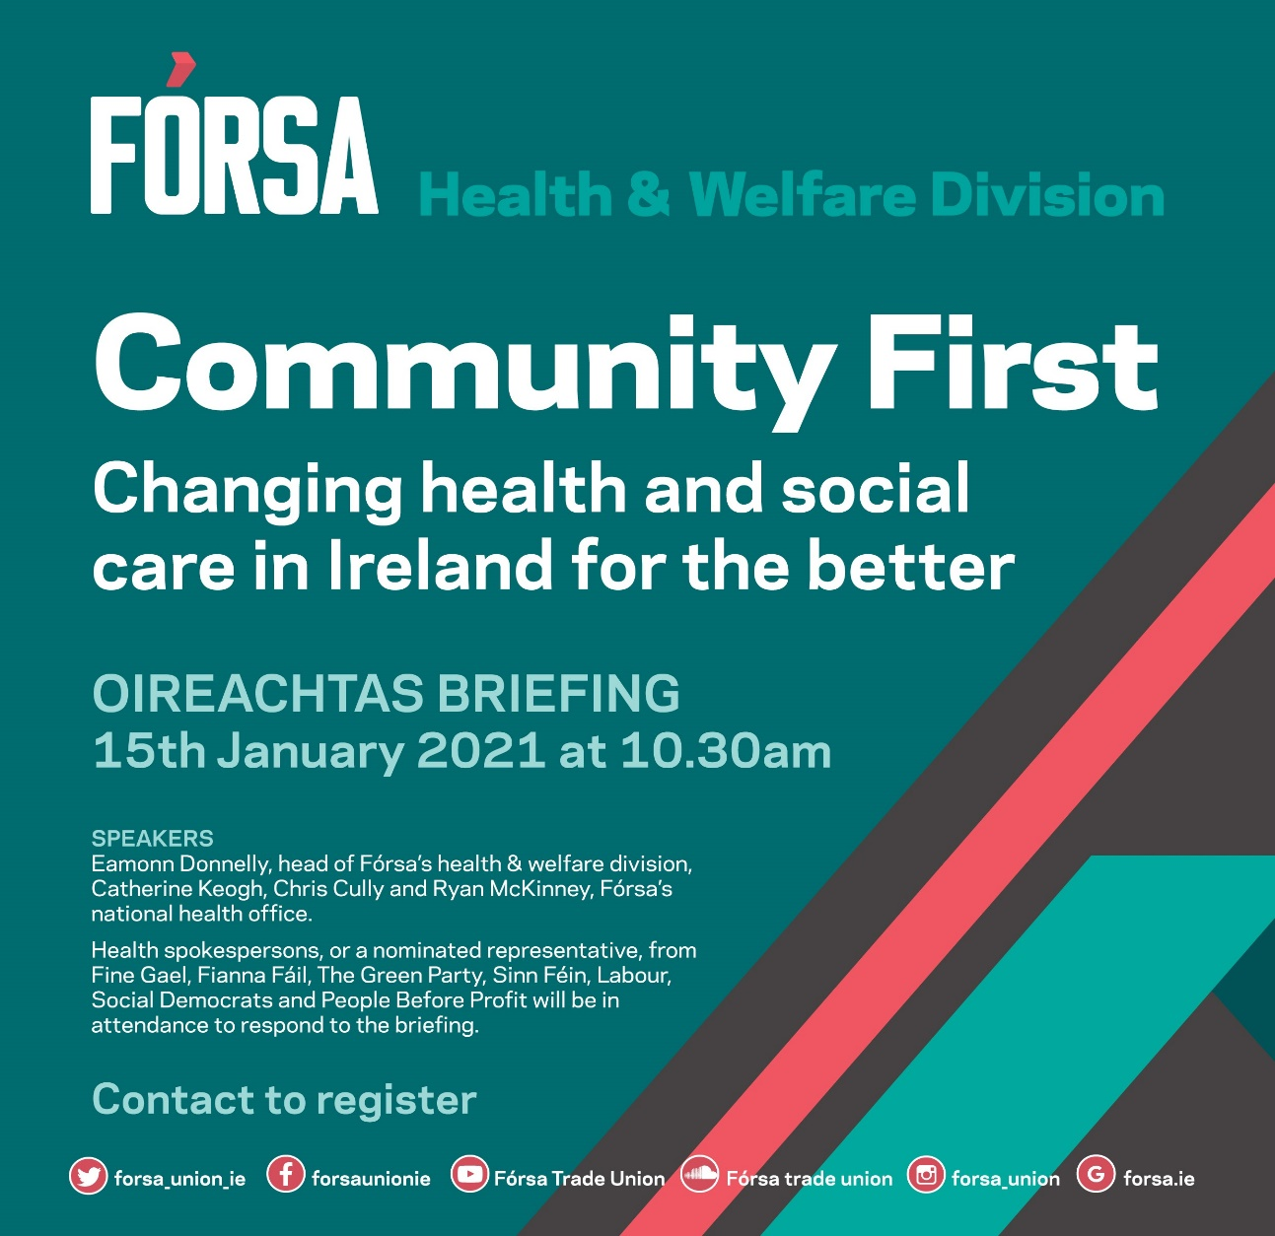

- The scheduled Fórsa Oireachtas health and social care briefing of political spokespersons on December 11th unfortunately had to be postponed for technical reasons. However the event was rescheduled for January 15th, and held successfully. The event was titled “Community First - changing health and social care in Ireland for the better”. It offered an opportunity for the union to discuss the key role our members will play in transitioning our health services to the community-led intervention model envisaged by the Sláintecare plan.
- The event enabled us to engage with healthcare spokespersons and representatives from each of the major political groupings in the Oireachtas. The purpose of the event was build profile and political awareness regarding the members Fórsa represent in health and social care and to outline their key concerns, to set out Fórsa’s position on the future of health services in Ireland, and to develop networks and relationships with key politicians. It is our intention to hold further briefings of this nature to continue to develop this.
- Fórsa members who registered for the event were enabled to attend and view the proceedings, and to input questions for Fórsa’s health officials and the public representatives via the chat box. All registrants who had expressed an interest but were unable to attend the event on the day were provided with a Youtube video recording of the event to watch back.
- We have engaged the independent researcher Brian Harvey to carry out the work to refresh Fórsa’s 2015 ‘Caring – at what cost?’ research on Section 39 funding. Brian is a well-regarded expert on the community and voluntary sector in Ireland, and has extensive research of carrying out research work in this area. It is our intention to utilise this updated research to inform and reignite our campaign on pay and conditions for workers in Section 39-funded agencies in collaboration with SIPTU. Work has already commenced on surveying members working in the sector and employers, as well as 10 expert interviews with workers and their representatives, academic experts, advocacy groups, policy makers and practitioners.
More Power to You
The campaign for stronger local government and better local services

- A presentation on phase 2 of the More Power to You campaign was delivered to the meeting of branch campaigns officers held on January 12th 2021.
- A meeting of the MP2U partner unions was held on January 13th to discuss the timeline and rollout of the new campaign. A further meeting has been scheduled for January 27th.
- The work plan for phase 2 of the campaign was previously circulated to members of the NEC.
Cabin Crew / Aviation Industry campaign

- Briefing document – A briefing document has been finalised for members of the Oireachtas transport committee and other relevant TDs and Senators on foot of the findings of the cabin crew branch survey. The sets out to complement existing commentary and contributions by the union and assist in building networks with relevant politicians.
- Political outreach – Following the approval of the briefing document, members of the cabin crew branch campaign sub-committee will be involved in political outreach efforts.

Housing – ‘Home for Good’ Campaign
- The AGM for the Home for Good campaign was held in December 2020.
- Fórsa continue to be active members of the steering group for this campaign, and additionally will now be members of the board.
- Meetings of the steering group and the ‘Building the Coalition’ sub-group were held in January 2021. Representatives from the campaign also addressed Fórsa’s BCO meeting on January 12th and participated in an engaging discussion with union campaign officers on the housing crisis.

Additional Items
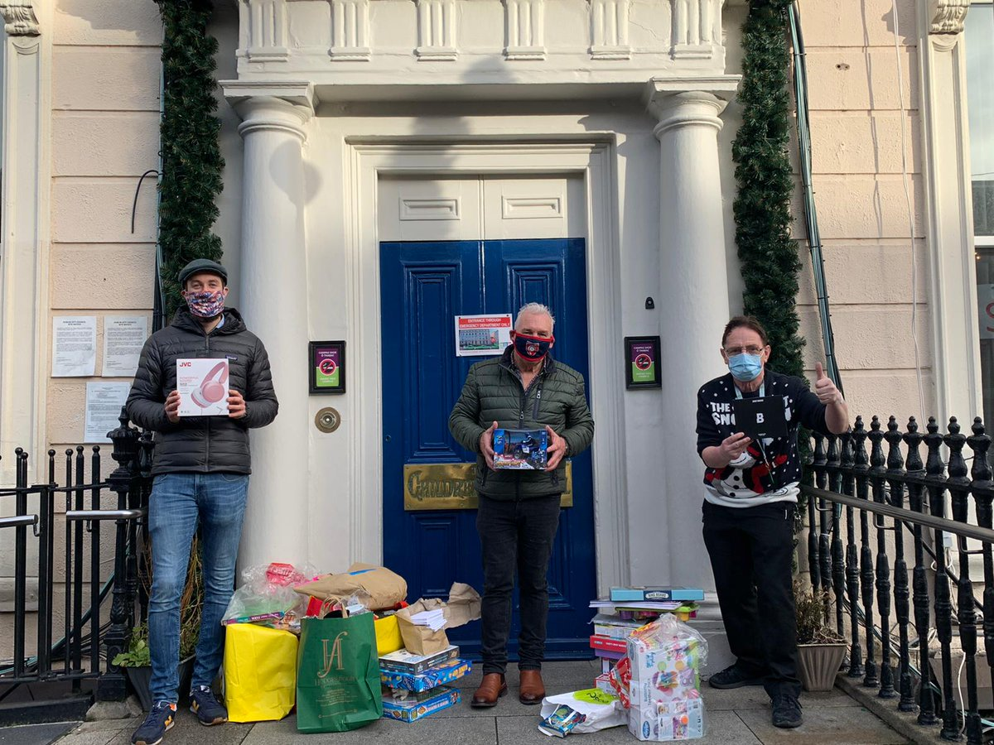
- Branch Campaigns Officers Web Event - A meeting of branch campaigns officers will took place on Tuesday, January 12th. This was attended by over 60 branch campaigning representatives, including many new BCO’s attending their first meeting. The agenda included presentations on the role of the branchcampaigns officer, Fórsa’s 2021 campaigning work programme, and the Four Day Week Ireland and More Power to You campaigns. Breakout group sessions of BCOs across each of the Fórsa divisions were held to encourage participation and contributions from all in attendance – topics discussed in the groups included divisional campaign priorities, establishing local campaign groups across branches, and supports and resources required for BCOs. The meeting was also addressed by external guest speakers from the Home for Good campaign.
- Fórsa Toy Appeal – As is now tradition, Fórsa’s staff and branches once again donated extremely generously to the Temple Street Toy Appeal. The presents were dropped off to Temple Street on Friday, December 18th and collected by Temple Street’s hospital porter John Doyle.
- Combating the far right – Fórsa were represented at a meeting held by the Irish Congress of Trade Unions to discuss and develop a social media campaign to combat the online threat posed by far right groups in Ireland, and their efforts to negatively influence public health messaging on masks and vaccines. This campaign will commence with a ‘Pro Mask if Pro Worker’ social media day.
- CETA – Fórsa contacted public representatives seeking postponement of the scheduled Dáil vote to ratify the EU-Canada Comprehensive Economic and Trade Agreement (CETA), and reiterating the Congress position on CETA.

