**CAMPAIGNING**

**Four Day Week Ireland**

***The campaign for a shorter working week***

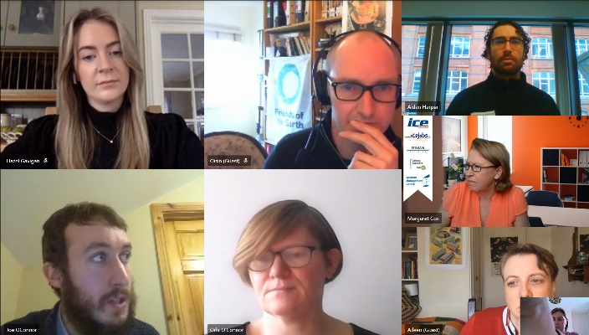 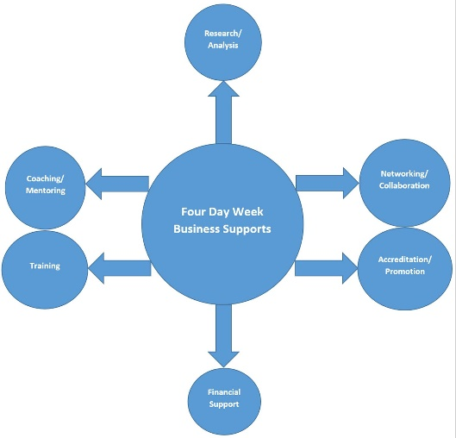

* Fórsa have represented the Four Day Week Ireland campaign at a number of 4 Day Week Global strategy and planning meetings. A team in the U.S. have agreed to develop an international four-day week petition campaign, to drive support for a coordinated international pilot of the four-day week campaign. It is intended to launch the petition in May, in advance of a ‘test pilot’ in September, and with a full rollout of the pilot programme in January 2022. Meetings to develop and progress this took place on 25th January, 1st February, 4th February and 16th February.
* Plans are continuing apace to develop a ‘Four Day Week Institute’ to provide business supports to companies who participate in the pilot programme (and meet particular conditions around hours, pay, and trade union access). This entails:  
  - Academic Research and Analysis: A number of meetings have taken place with researchers in UCD, Maynooth and NERI to discuss this. It is hoped to finalise an agreement with a research team by April.  
  - Training: Work has commenced on delivering the training programme and materials.  
  - Coaching & Mentoring: Agreement has been reached with a number of international business leaders to participate and offer coaching and mentoring supports.  
  - Accreditation: A promotional ‘tick’ for employers who meet the conditions and participate in the pilot.  
  - Networking & Collaboration: Enabling businesses who are participating in the coordinated pilot to share learning and experiences.
* The campaign intends to engage with the Government in the coming months to seek their support as part of the pilot programme, in two ways:  
  - (1) To set up a €5m fund to provide financial support to private companies who participate in the pilot programme (in line with the €50m pilot fund recently announced by the Spanish government)  
  - (2) To commit to trialling the four-day week in at least one local authority and one civil service department, and to set up an application process to enable this.
* A meeting of the Four Day Week Ireland steering group took place on 17th February. The update presentation delivered at this meeting has been circulated with this month’s NEC papers.
* A meeting took place on February 2nd with the Language agency who developed the branding and materials for the Four Day Week Ireland campaign launch, to agree a work plan to update and refresh the campaign website, and to expand the campaign’s social media presence through developing a content repository and calendar.
* Following a meeting with Paul McNulty, CEO of Donegal-based software firm 3D Issue who have recently introduced the four-day working week for their employees (with no loss of pay), he has agreed to join the campaign coalition.

**Collective Bargaining**

* A Fórsa response to the Government’s consultation on the EU Directive on Adequate Minimum Wages is currently being prepared. The deadline for submissions is 19th February.
* Fórsa have commissioned a research project on collective bargaining rights in Europe. This will entail two phases:  
    
  - (1) Situating collective bargaining in Ireland in context, through a comparative study of 3 other member states of the EU (grouped based on strength of collective bargaining rights, degree of collective bargaining coverage, and the levels at which bargaining is generally conducted).  
    
  - (2) Examining the position of collective bargaining in existing obligations under EU law and in the context of the proposed directive on adequate minimum wages; extracting principles to guide Irish legislative action to comply with these EU obligations and enhance collective bargaining in this jurisdiction.  
    
  Meetings were held on 27th January and 1st February to finalise and agree the brief for this project, and the work has now commenced. It is anticipated that this work will conclude at the end of April.
* Exploratory work has commenced on the principles for a public communications campaign on collective bargaining. Initial meetings to discuss this, as well as the Fórsa research project, have been held with relevant officials in ICTU (11th February), FSU (25th January), and SIPTU (18th February).
* We attended a webinar held by SIPTU on ‘Workplace Democracy’ on 3rd Febuary.

**Campaigning in Education**

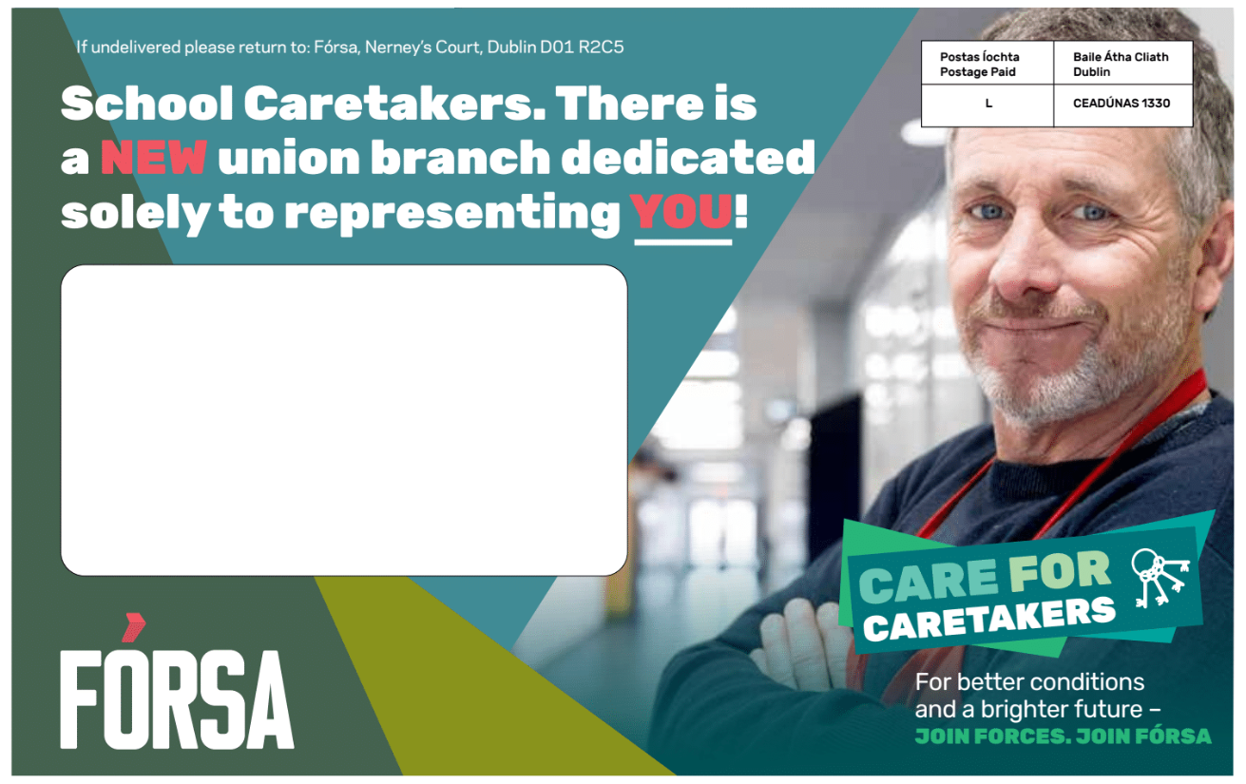 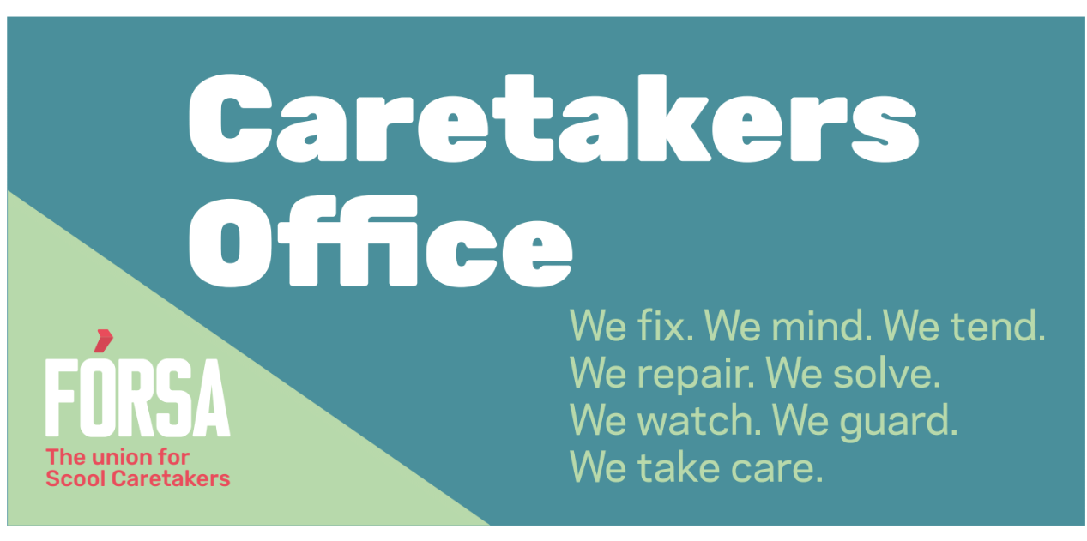

* The branding, messaging and materials for Fórsa’s ‘Care for Caretakers’ school caretaker recruitment campaign have been finalised and agreed. The launch of this campaign has been delayed pending the safe and successful re-opening of schools. It is anticipated that the fulfillment and distribution of ‘Care for Caretakers’ campaign packs to all schools in the country will take place on the second or third week after the return of all schools.
* Continued political engagement took place with key public representatives in relation to the Government’s school reopening plan, in particular with regard to health and safety issues and the concerns of Fórsa’s SNA members. This included the organisation of a meeting with Sinn Féin leader Mary Lou McDonald on 26th January, and regular contact with Oireachtas education spokespersons from both Government and Opposition parties.
* At a meeting of the ‘Education Futures’ higher education campaign coalition this month, it was agreed to set out a plan of work for the coming 18 months. It was similarly agreed to establish a number of sub groups for the campaign to broaden our reach and increase our workload capacity in the coming year.

**Branch Campaigns Officers**

* Following feedback from branch campaigns officers at the discussion groups held as part of the BCO meeting on 12th January, a number of actions have been agreed, including:

- 2-day training for new BCOs (and as a refresher for more experienced BCOs) will be held on March 4th and 11th, and March 5th and 12th. It will be led by Pat Montague, and will include practical workshops on political lobbying, public speaking, confidence building and engaging with local media. Catherine Raynor from Mile 91 will also present on storytelling, while an update briefing presentation on the progress of Fórsa’s current campaigns will be delivered.

- A ‘buddy’ system where experienced BCOs will mentor new BCOs is being put in place, and a call for expressions of interest for this has gone out.

- We are also asking BCOs to complete a consent form to enable other BCOs in their division or county/region to contact them directly, following requests from many of the groups.

**More Power to You**

***The campaign for stronger local government and better local services***

* A meeting of the 3 partner trade unions (Fórsa, SIPTU and CONNECT) for the More Power to You campaign was held on the 27th of January.
* External support is now being engaged to develop a campaign video, update the campaign materials, and design the presentation to be delivered to local councils.
* The work plan for phase 2 of this campaign was previously circulated to members of the NEC.

**Housing – ‘Home for Good’ Campaign**

* Meetings of the steering group and the ‘Building the Coalition’ sub-group were held this month.
* The group is scheduled to meet with the Minister for Housing Darragh O’Brien on the 23rd of February. The purpose of this meeting is to discuss the campaign and potential wording for the referendum.

**Cabin Crew - Aviation Industry campaign**

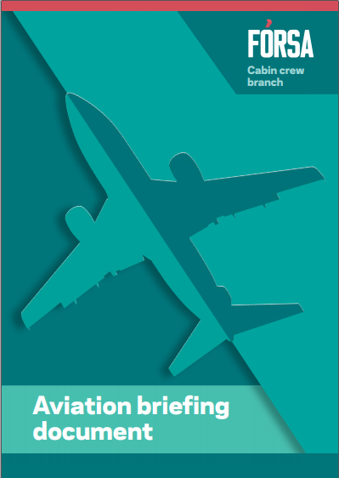

* **Briefing Document –** This briefing document has been approved and distributed to members of the Oireachtas Transport committee.
* **Political Outreach –** Meetings have taken place or been scheduled with Fianna Fáil, Fine Gael, Labour and Sinn Féin.

**Campaigning in Health**

* Significant progress is being made with the union’s research on ‘Section 39’ funded organisations, which is being carried out by independent researcher Brian Harvey. The purpose of this is to update the ‘Caring – at what cost?’ report published by IMPACT in 2015, with a view to informing a refreshed campaign for better working conditions for workers in State-funded voluntary health organisations. Surveys have issued to hundreds of employers and thousands of workers in the sector, and interviews have been held with 12 ‘experts’ from the perspectives of workers, IR practitioners, employers and policy makers. It is anticipated that this research will be completed next month.
* A Youtube link with the recording of the rescheduled ‘Community First’ Oireachtas health briefing event that took place in January, was issued to all those who registered for or expressed an interest in the initial event date in December. **Additional Items**

 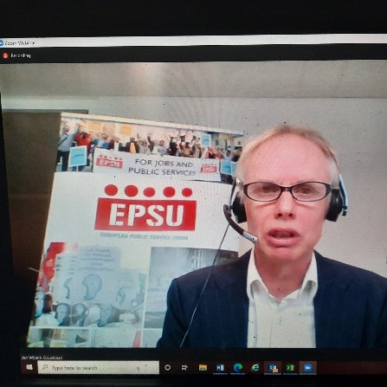

* **European Conferences –** Fórsa were represented at the ETUC/ETUI conference ‘Towards a New Socio-Ecological Contract’ from February 3rd to 5th, and the EPSU seminar ‘Innovative approaches to union recruitment and retention of university students’ on February 17th.
* **CETA –** Fórsa contributed to ICTU’s response to Tánaiste Leo Varadkar in relation to our concerns around the ICS (Investor Court System) aspect of the CETA deal, and supported a letter to the Irish Times from a coalition of civil society organisations regarding the ICS.
* **Future of Work Interview –** Fórsa’s Director of Campaigning will participate in an interview on the Future of Work with the Europe Direct Information service on February 19th.
* **Work Programme** – Fórsa’s campaigning work programme is under constant review to adjust to developments at national and divisional levels. We have tentatively began exploring the possibility of research on ‘A New Vision for the Role of the State in a Post-Pandemic World’.
* **Work Placement Student** – A work placement student from Maynooth University, Ross Murray, commenced his work experience with Fórsa’s campaigns section on February 1st. He is working with the team on Mondays and Tuesdays through to May.