**CAMPAIGNING**

**Campaigning Review / 2021 Work Programme**

* A review of all current and ongoing public and political campaigns has been completed, and a new campaigning work programme for 2021 has been developed which is aligned with Fórsa’s strategic, industrial and organising objectives.
* A presentation on this review and a spreadsheet containing the work programme have been circulated with the papers for this NEC meeting.
* The review was informed by meetings with heads of division which took place in November to discuss campaigning priorities, resourcing and sequencing. The new work programme contains an agreed approach to immediate priorities, ongoing activities and future developments within resource parameters.
* The following factors were also considered in conducting the review and developing the agreed work programme:  
  - Mix of national and divisional priorities  
  - Current resource allocation and future resource requirements  
  - Impact of COVID19 pandemic on campaign activities  
  - Progress made to date towards intended outcome, and assessment of current position  
  - The strategic objectives contained in Section 3 of Fórsa’s strategic plan on ‘Campaigning and Influencing’   
  - Relevant campaigning motions passed at Fórsa’s national conference by the NEC and branches

**Four Day Week Ireland**

***The campaign for a shorter working week***

* A presentation was made to the civil service divisional executive on the Four Day Week Ireland campaign on November 26th.
* Fórsa participated in an international four-day week campaign meeting on November 27th.
* An opinion piece in The Irish Sun on the four-day week was published on Sunday, November 22nd (<https://www.thesun.ie/news/6180560/four-day-week-work-smarter-longer-productivity/>), and a number of regional radio interviews on the campaign were conducted during this period.
* We are continuing to advance work on potential four-day week pilot programmes which will be supported by academic research.
* We are also preparing a response to the question on the four-day week raised at the Citizens Assembly on gender equality.

**Cabin Crew / Aviation Industry campaign**

* **Aviation Seminar –** On the 2nd of December, Fórsa assisted with the organization of a seminar hosted by ICTU on the challenges facing the aviation industry. The panelists for this event were industry leaders and trade union officials, and it was addressed by Minister Hildegarde Naughten and ICTU general secretary Patricia King. Fórsa general secretary Kevin Callinan moderated the event.
* **Survey –** Fórsa surveyed over 500 members of the cabin crew branch in the last week of November and first week of December. The survey focused on areas of concern arising from the Covid-19 pandemic.
* **Briefing document –** A briefing document is being drafted for members of the Oireachtas transport committee and other relevant TDs and Senators on foot of the findings of the survey. The document will set out to complement existing commentary and contributions by the union, and assist in building networks with relevant politicians.

**School Caretaker Recruitment Campaign**

* A meeting took place with schools organisers on 18th November to brainstorm on maximising recruitment of school caretakers, building on the successful approach to building profile adopted in the ‘Support our Secretaries’ campaign which led to the increase in branch members by over 50% from the beginning of 2019 to date. This will utilise similar tactics, channelling Fórsa members working in schools (SNAs and school secretaries) and school principals as a conduit, and using direct mailing to reach school caretakers.
* A survey has been designed on school caretaker demographics and issues, to learn more about this group of workers and to inform our campaign messaging. This is being distributed to existing Fórsa members via phone banking being carried out by campaigning staff and schools organisers, and to non-members via email and Whatsapp from SNAs and school secretaries. An email to all school secretaries was distributed to this effect on December 7th, and this call to action will feature in the next education bulletin.
* A briefing meeting with the creative agency who worked on the ‘Support our Secretaries’ campaign was held on December 4th, attended by the Head of Division, Director of Campaigning, and Lead Organiser. They will be carrying out work with Fórsa on branding and messaging for this campaign, and the development of materials for campaign packs. They will also manage the print, fulfillment and distribution of campaign packs addressed to school caretakers to every school in the country in January. This will be complemented by supporting materials for SNAs, school secretaries and school principals. This work will be informed by the results of the survey, in addition to one-to-one interviews and a consultative group meeting with school caretakers.

**Campaigning in Health**

* 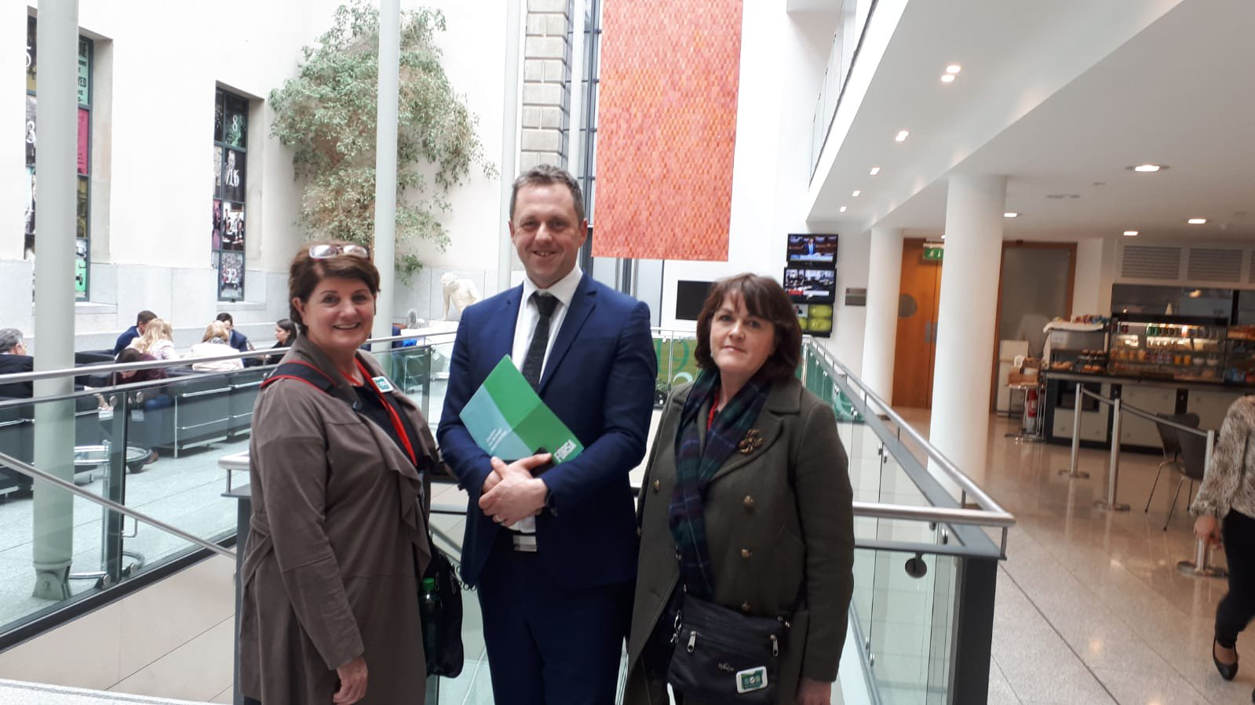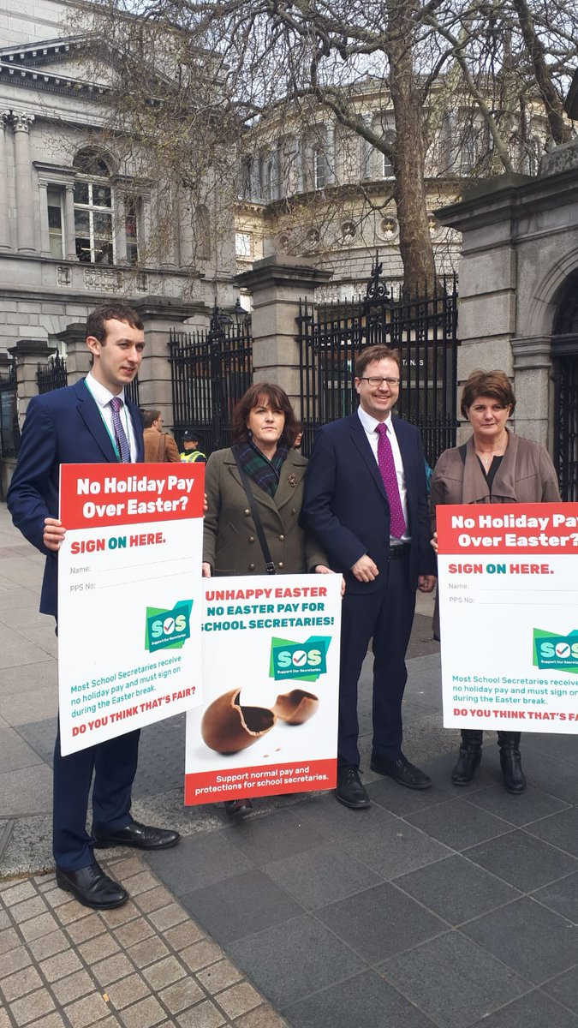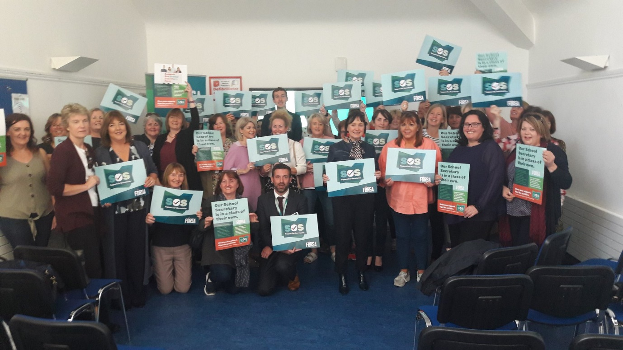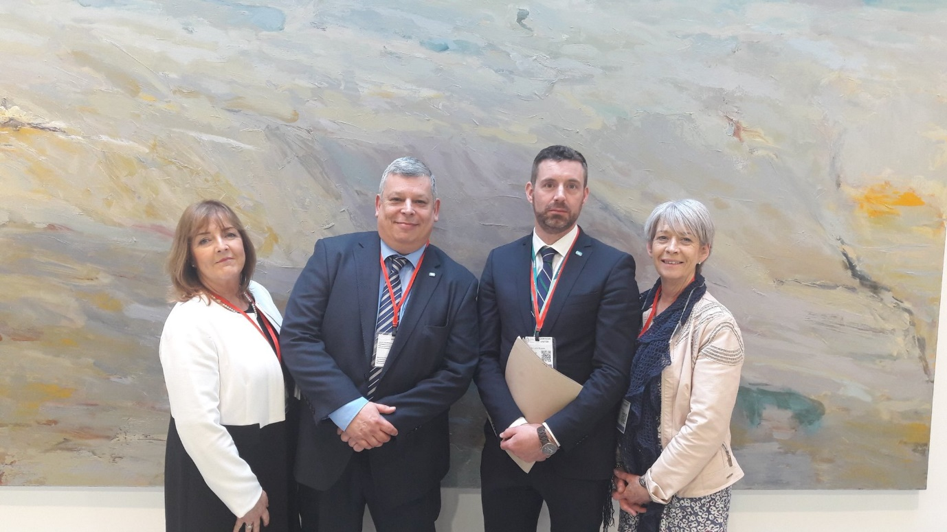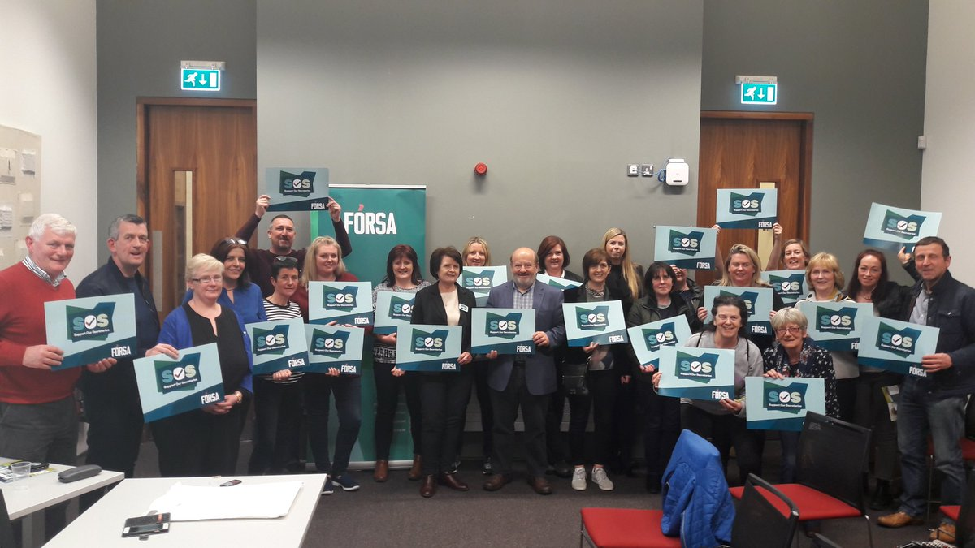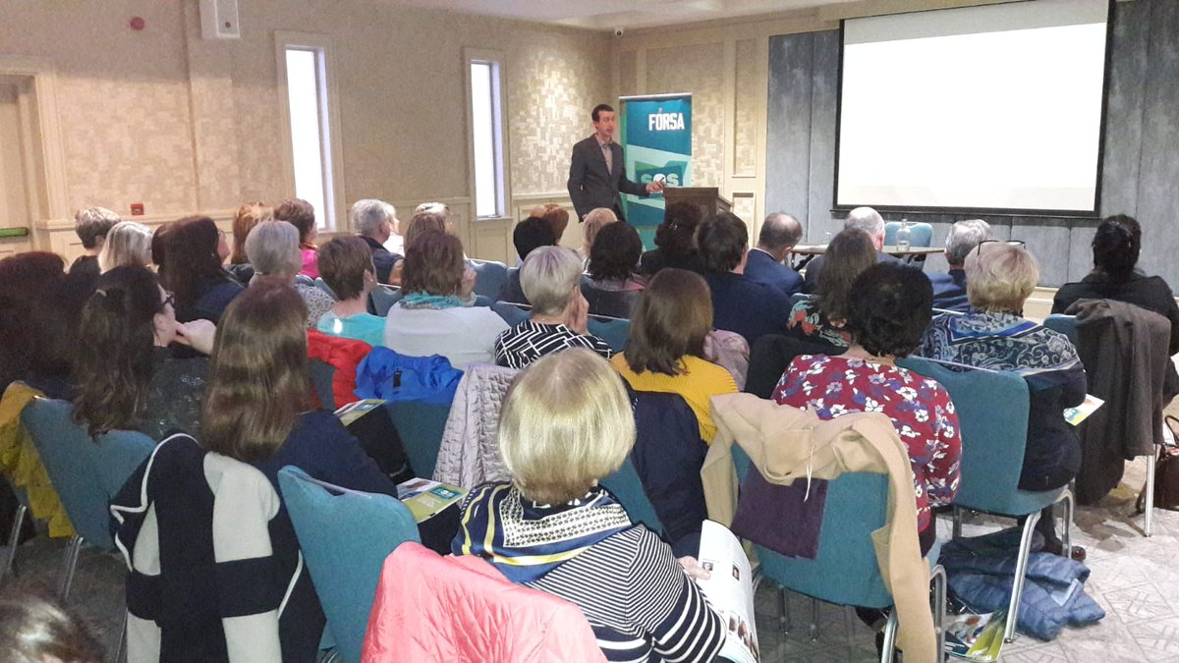
* Fórsa are hosting an Oireachtas briefing of health political spokespersons on December 11th at 10.30am. The event is titled “Community First - changing health and social care in Ireland for the better”. It offers an opportunity for the union to discuss the key role our members will play in transitioning our health services to the community first approach central to Sláintecare.
* The purpose of the event is build profile and political awareness regarding the members Fórsa represent in health and social care and to outline their key concerns, to set out Fórsa’s position on the future of health services in Ireland, and to develop networks and relationships with key politicians.
* The event will also be a “live lobby” which gives members and the general public an opportunity to watch the proceedings and interact with contributors during the session. Almost 100 people have registered to attend so far. All major political party groupings represented in the Oireachtas will be in attendance and contribute at the event.
* A poster with further details on this event has been circulated with the papers for this NEC meeting.
* Work has commenced to refresh Fórsa’s 2015 ‘Caring – at what cost?’ research on Section 39 funding, and to reignite our campaign on pay and conditions for workers in these agencies in collaboration with SIPTU.
* The national health team have also identified mental health service funding as an immediate campaigning priority area for the union. Additionally, we will begin development of a Fórsa community campaign on universal healthcare early in 2021, with a view to launching in September 2021.

**More Power to You**

***The campaign for stronger local government and better local services***

* A work programme for phase 2 of this campaign has been agreed, and a note was prepared and circulated to the Local Government Divisional Council setting out next steps and plans for 2021.
* This has been circulated with the papers for this NEC meeting.
* A meeting with the other MP2U partner unions, SIPTU and CONNECT, is being scheduled for the start of January.

**Housing Campaigns  
  
*Raise the Roof***

* The Congress-led Raise the Roof campaign hosted a webinar on the 27th of November on the housing crisis. The event included expert panelists and contributors, and political party spokespersons on housing.
* Over 300 people registered for the event, and it will be the first in a series of webinars to be hosted by Raise the Roof on the topic of housing and homelessness.

***Homes for Good***

* Fórsa have been the trade union representatives on the campaign steering group of Homes for Good, the campaign for a right to housing, since the inception of the campaign.
* Following a commitment in the programme for government to a referendum on the right to housing, the campaign has now established a number of sub-committees.
* Fórsa are members of the “building the coalition” and “winning the referendum” sub-committees. Each of the committees have held initial meetings, and will be drafting specific work plans before the Christmas break.

**Additional Items**

* **Branch Campaigns Officers Web Event -** A branch campaigns meeting will take place via WebEx on Tuesday, January 12th. This will be attended by current and potential branch campaigns officers, and nominated branch representatives. The agenda will be finalised in the coming week, but it will include items on the role of the branch campaigns officer*,* Fórsa’s 2021 campaigning work programme, Fórsa national campaign priorities, and breakout group sessions Fórsa divisional campaigns.
* **Fórsa Toy Appeal –** Fórsa are once again supporting the Temple Street Toy Appeal. We are encouraging staff and branches to deliver suitable unwrapped new toys to *Fórsa Toy Appeal, Fórsa Trade Union, Nerney’s Court, Dublin 1.* These will be collated and dropped off to Temple Street on Friday, December 18th.
* **Fórsa Conference -** The Director of Campaigning contributed to a video developed for Fórsa’s virtual conference on November 19th to review the highlights of Fórsa’s first three years in existence, discussing some of the major campaigns the union have engaged in over this time period.